Notable Events
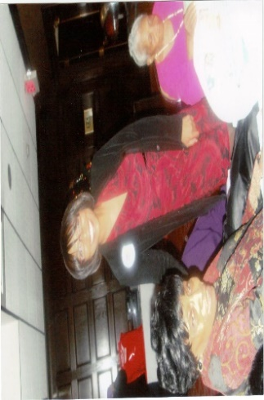
Christmas 2013
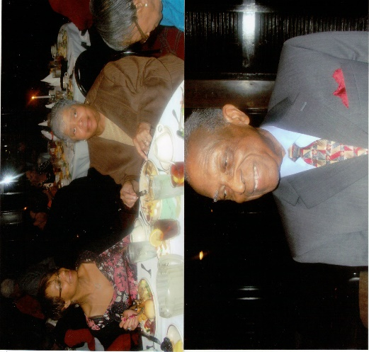
Every year we celebrate Christmas with our invited guests and one another. We fellowship, dine and remember the meaning of the season with carols and a scriptural play or game written and directed by our Executive Board President, Julia McFarlane. December 2013 we were delighted to have three of our instructors in attendance Dr. Ida C. Robinson, Dr. Ivy Nelson and Dr. Martha Lewis Smith. Dr. Robinson was accompanied by her daughter who was a candidate for a D.C. Council seat. We were honored with the return of Glendalyn Allen, class of ’62 who has moved to SC to be closer to her daughter. Other long time members who continue to support us and attend meetings also celebrating with us were Evelyn B. Tuckson, class of ‘48, Catherine Briggs, class of ‘47 and our first male graduate, Wesley Branch, class of ‘59. Closing remarks were extended by DC club president Carol Johnson. A lovely night ended with the singing of “Silent Night “ by Mr. Samuel Hooper, the husband of Marcia Jackson-Hooper, class of ’68
Join us for Christmas 2014. Put FHNA Clubs on your calendar. See you there!!!!
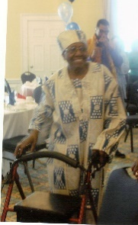
Celebrating her 95th
On Saturday the 8th of April 2014 Beatrice C. Fuller celebrated her 95th birthday at the Officers’ Club at Fort McNair, Washington D.C. It was attended by a host of relatives and friends. She experienced a fall in 2013 fracturing her hip but her grand entrance with walker showed her resolve. She loves to dance and did so (wheelchair and all). In June 2014 she joined us at the DC club’s end of the year event luncheon held at the McCormick and Schmidt restaurant at the National Harbor .
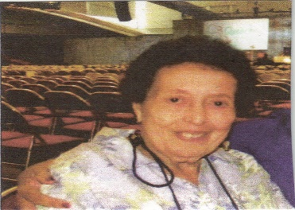
Charlotte Payne Reid, class of ’47 received special recognition as an “Unsung Hero” at the LWML Convention held June 2013. She is a member of Mt. Olivet Lutheran Church in Washington, D.C. where she has been a member since 1955. She was surprised and honored to receive this recognition. She remains active in serving others even at the age of 90.
A Neighborhood Tradition Reopens!
Earline Sampson, Class of ‘61, and her family re-opened the popular VIP Room in October 2013. The Club was originally opened in 1978 by Abner “Bam” Sampson but has been closed for the last decade. Mr. Sampson wanted a place where neighbors and friends could come and enjoy themselves while feeling classy and important- just like a Very Important Person aka VIP! Family members- Earline and her children Bo, Mike, Gary, and Yolanda Sampson, view the reopening of the club as a way to honor and pay tribute to her late husband and their father

In Memoriam
2013
Beatrice Sorrell, class of ‘41
Mother of Barbara Isaacs, class of “63
Yvonne T. Love, sister of Thelma Wheeler, class of “47
Lt. Col. (ret) Allen Broussard, brother-in-law of Barbara H. Elzey, class of “65
Dr. Charles Hall, OB/GYN
2014
Ether Mae Chavis Sims, class of ‘52
Esther Wallace Swiner, class of ‘55
Loris Dubois Barnes Hill, class of ‘61
Alfred Boyd, husband of Gladys W. Boyd, class of ‘61
Henry Wineglass, husband of Josephine A. Wineglass, class of ’63 and brother of Gladys Boyd, class of ‘61
Tanya Patterson, granddaughter of Thelma Wheeler, class of ‘47
Kenneth Rose, nephew of Thelma Wheeler, class of ‘47
Jocelyn Yankey, daughter of Lucy Yankey, class of “73
Errol H. Robinson, husband of June Robinson, class of ‘60
Margaret Madison – who served as the practical nurse instructor at M.M. Washington for many years at Freedmens and Howard University Hospitals

A Gentle Reminder !!! Keep our sick, shut-in, and homebound close with cards, letters, phone calls, e-mail, smart phone, social media.

From the Executive Board

Dear Fellow Alumni Members:
What does your Alumni Association mean to you? I ask this question for we are on the road to the demise of Freedmen’s Nurses Alumni Clubs, Inc. We have a nominating committee that cannot function. We have no viable candidates for President-Elect. The last President has not shown or resigned since she was elected. I have been in a leadership position for our organization for the last 14 years and it is time for me to set down and I am going to do just that. If you have any desires to keep this 120 year organization going then step up to the plate or we are in our final inning. Some of the members are planning the Reunion for 2015 and looking for your support. It has been a labor of love for Freedmen’s School of Nursing gave the tools for me to be successful in my chosen profession and I have paid my dues. I challenge you to take up the gauntlet.
Yours in Service,
Julia Varner McFarlane, Class of ‘69
President- Elect

SCHOLARSHIP

Thank you for supporting the scholarship fund. $1510.00 has been donated thus far. In 2013, 5 scholarships totalling $4500.00 was awarded.
Awards were presented Kiyane Perez attending Old Dominion University in Norfolk, VA., Diamond Austin a student at University Of Alabama at Birmingham, McKala Ebony Cole Moore at the University of North Carolina Greensboro.

Contributor$ to the $cholar$hip Fund
Euphazine Reid Kendall Lizzie Graham Freddie W. Grice
Salonie B. Turner Olive Glasgow Annie Lawrence
Loris Hill Glendalyn Allen Elsie Bell
Cheryl Sadler Vernestine Sherrod Brenda Tuckson
Ida Pohill Jacqueline Williams Patricia Gibbs
Edna Pruce Marcia Neal Mary Bush
Barbara Eldridge Blanche Newton-Finch

Julia Varner McFarlane, class of '69 and I went to HU to tell our stories in their Legacy Initiative.
We talked about FHSN and what happened in school and the world while we were there.
Our stories will be in the Smithsonian as well as at Howard. We had pictures taken for the Smithsonian as well as Howard, received a folder explaining the initiative, a CD, and a figurine of the occasion.
Everyone said ours was the best stories. They did not know that the TV station was in the Freedmen's building.
Don't we (FHSN nurses) always be the best at whatever we do?

Venita Rich Atkins class of "64

D.C. Club

Greetings Alumni,
As President of Freedmen’s Nurses Alumni Clubs, Inc – DC Club I want to thank all local and at-large members who continue to support our Alumni. Your dues and scholarship donations enabled four students to receive scholarships this year. We are grateful that you recognize the legacy of Freedmen’s Hospital and the educational opportunity it afforded you and the many blessings you have received having been a nurse that graduated from Freedmen’s. I still marvel at the responses when I mention Freedmen’s, it is either I knew a nurse who went to Freedmen’s or I was born at Freedmen’s. In like kind I marvel at those of you who support and pray that those of you who have not been able to support our alumni in the pass can find it in your heart to do so this year. I realize that times are hard, many of us have retired, but we have been blessed; and in turn I am asking that you return a part of that blessing to the Alumni in order to help bless someone else as they further their nursing education. The DC Club looks forward to welcoming many of you back to DC next year for our Triennial Reunion. I hope many of you will respond favorably when you received your reunion information. Remember, we are keeping the Freedmen’s Legacy alive.
Peace and Blessings,
Carol Helen Jones Johnson, Class of 19
$CHOLAR$HIP
The D.C club continues their awarding of scholarships as well. Two students at Bowie State University ,one student at Georgetown University and one student at New York University received $1000.00 scholarships.
Contributors to the Scholarship Fund
Minnie Bingham Ella Webster Janie L. Smith
Carol Johnson Marie R. Wright Julia MacFarlane
Sylvia Royal Judy Walker Ernestine Brogsdale
Venita Atkins Marcia Jackson-Hooper Hope Butler
Barbara Isaacs Evelyn Tuckson Beatrice Fuller
Barbara Miller Dorothy Pringle
Retirement is the time to travel – and travel we did. In August, 2013 my husband and I joined the Howard University Retires in a Wild- Wild West Train trip. We boarded the train at Union Station, DC, got off and boarded the California Zephyr in Chicago’s historic Union Station. Here we met our tour guide and were off to Salt Lake City. We then board a Motor coach and we had the same driver and tour guide for the rest of our journey. We saw the Mormon Temple and the Great Salt Lake. It does smell but it is tolerable. Salt Lake is a very clean town, no trash on any street; you are also ticketed for jay walking. From there to Montpelier, Idaho to visit the National Oregon/California Trail Center, here we learn about the North West passage and had a simulated wagon train ride. From there on to Jackson Hole Wyoming, everything there is made of Antlers. It is also a quaint little western town with lots of ski lofts. Also in Jackson Hole we visited the Grand Teton National Park, the mountain range rise 13,000 feet in the air, a beautiful sight to behold. Then on to Yellowstone National Park, a two- million acre national jewel. I was awe struck by the erupting of Old Faithful Geyser. About every 30 minutes it erupts, shooting water some 100 feet in the air. From Yellowstone to Glacier National Park in Montana where we stayed in a Swiss-style chalet and saw lots of forest, alpine meadows, and rugged mountains with their slow moving glaciers. Beautiful to see the sun shining and we still see snow. The snow is just that deep that it never completely melts from one snow season to the next. It starts snowing of and on in October and does not stop until March. We had a 14 day journey and we enjoyed every minute of it. That part of the country is different. Small towns with populations of 500, some even smaller. Wide open plains, lots of tumble weed. A wonderful place to visit, but it was great to get back on the east coast to see lots of greenery, traffic jams and lots of people. I highly recommend the trip.
Carol Johnson, class of “65
July, 2013 my cousin, Marilyn Jeter, and I went to Nassau, Bahamas with friends to celebrate the Bahamas 40th anniversary of Independence from England. We went to the official celebration, then downtown to the Junkanoo parade, which lasted all night.
We also went to the Blue Lagoon(where they made the movie) Water Park for a day. We also had a cook-out on the beach. Had a great time.
Venita Rich Atkins, class of "64

REUNION 2012
REFLECT ON THESE PICTURES AS YOU
GET READY TO ATTEND REUNION 2015

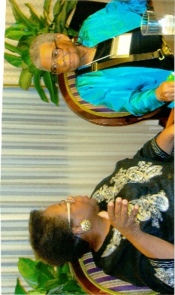

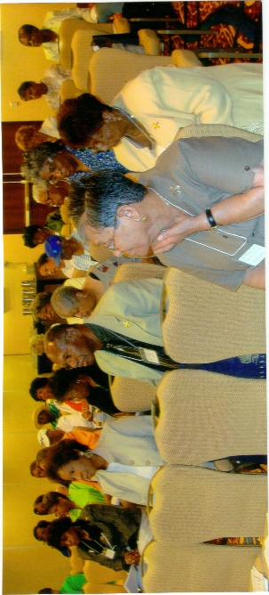
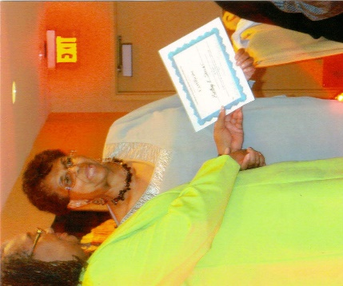
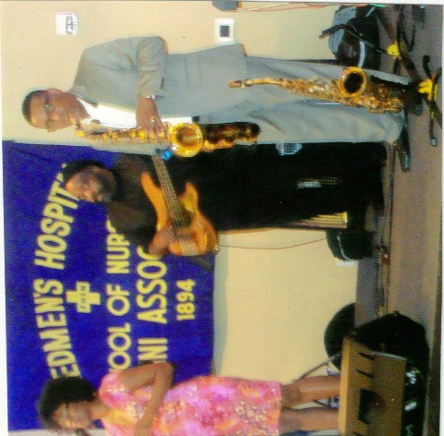
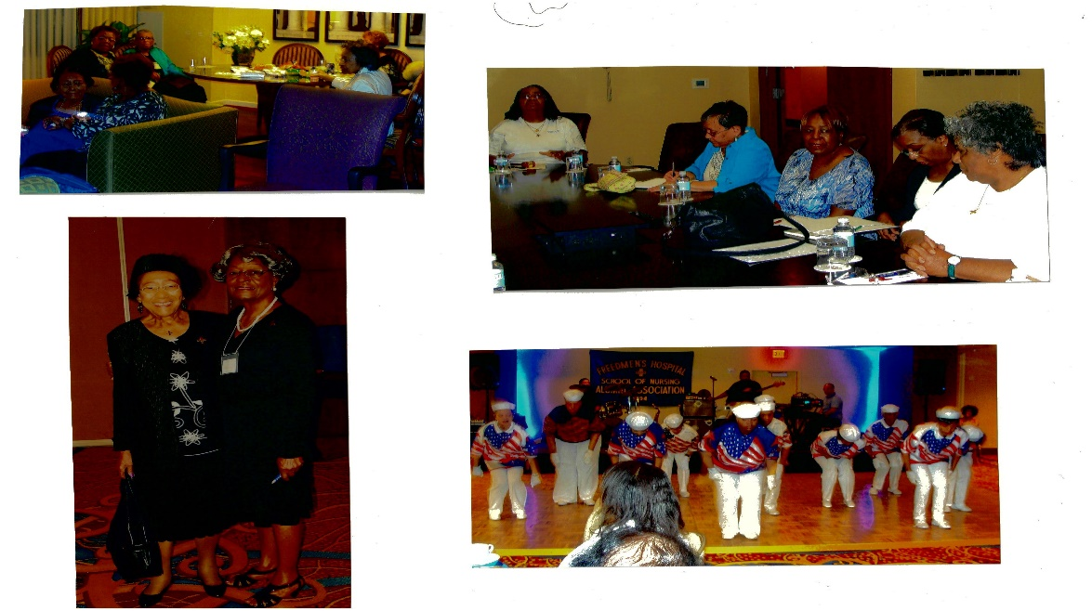

Plans for Triennial 2015 have commenced. Your chair is Kathy Senior, class of ’62. Reserve the dates of June 25 – 28, 2015. Expect more information soon!!!!

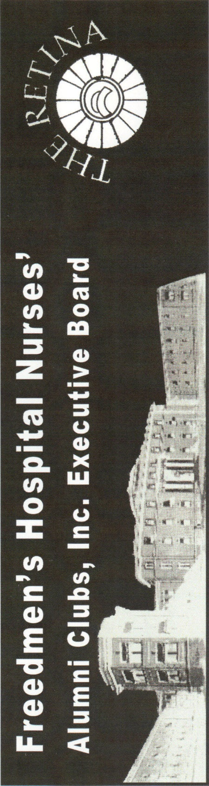
JULY 2014

Remembrance
s

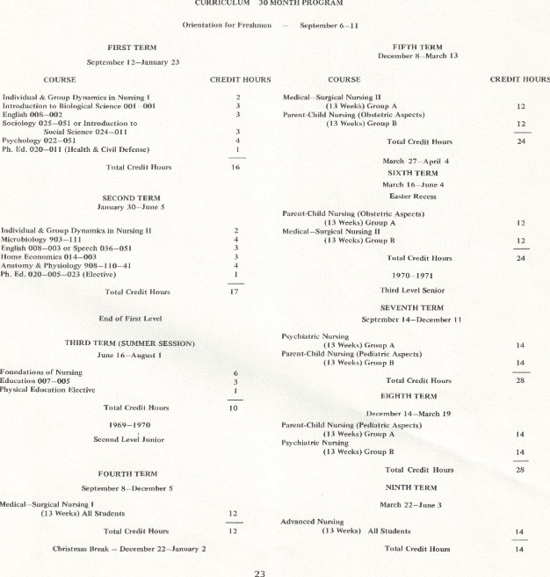
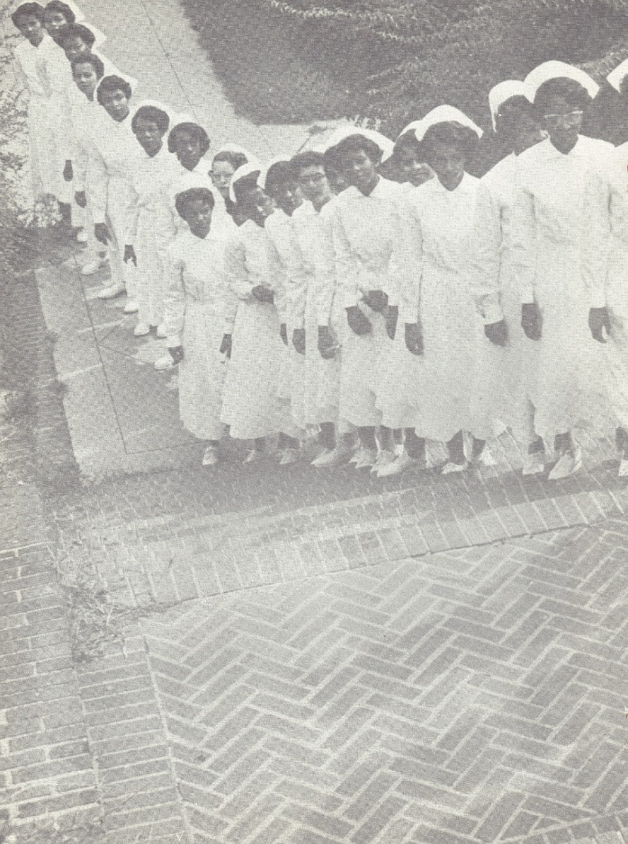
Do you remember????

Our Schedule!!
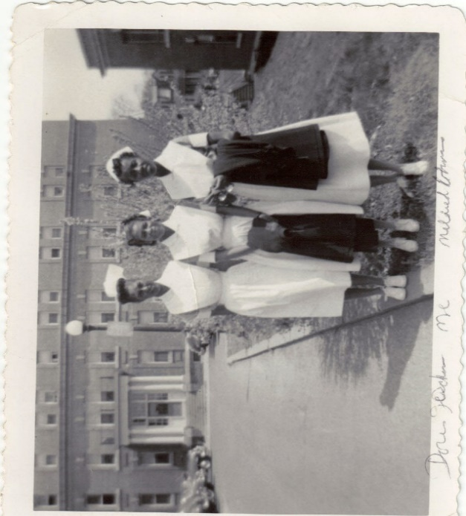
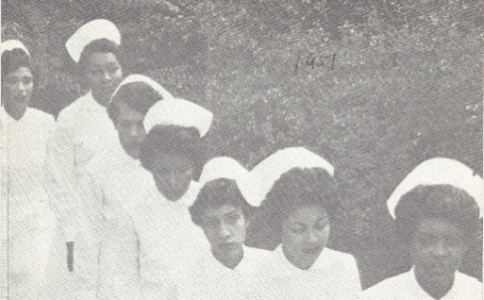
FRIENDS!!!! What is that building?

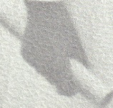

DIPLOMA IN HAND!!!!!

